BORDERS

The assignment features generation of triangles and arrows using borders of elements i.e. pure CSS also usage of pseudo styling and positioning.
Every element in html (except SVG) obeys the box model in which the content lies at the core outside that comes padding, then comes the border of the element and then the margin of the element.

Triangles:

Taking advantage of the box model we can create shapes such as traingles. So in order to do that we require elements which have no specified width and height only borders and thus we can give borders the specifed widths to achieve a triangular shape.
For creation of equilateral triangles we require only two borders, a coloured one and a transparent one. There are four corners to any element and we can take advantage of that to create any orientation of the triangle we require.
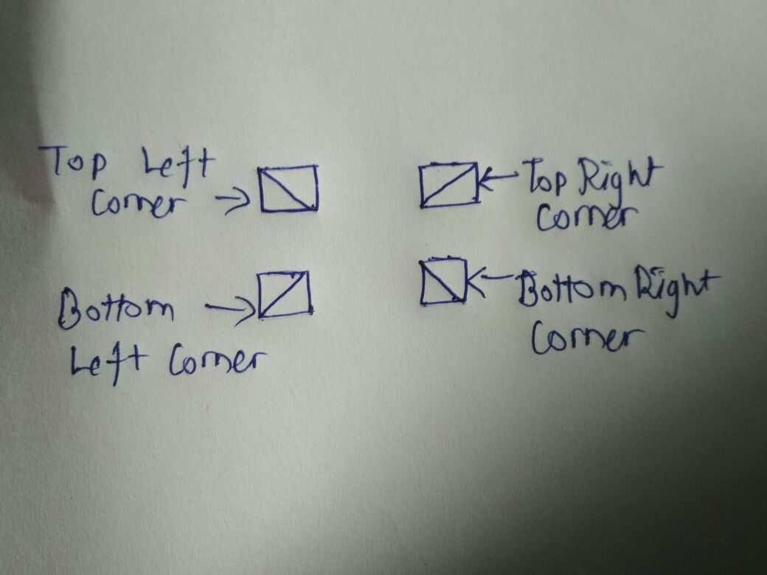

As we can see in the above figure we can have 8 triangles created just from identifying which corner of the box fits our requirement and we can thus pick up whatever two borders that suits us.

However, for creation of isoceles and scalene triangles we require a combination of three borders. Please refer the code of trianglles in which I have created and isoceles triangle.
An added advantage is that we can give multi coloured borders to the same element.

Arrows:

Here we require to have widths to the box, so that we can use it’’s borders to generate the shape of the arrow. Such arrows must be used only in cases of accordions or sliders (You can also use triangles for sliders or accordions in some cases).
The key here is to use rotation properties for the appropriate orientation of arrows. Properly choose which border needs to be choosed for what arrow we want to create so that the rotation turns out to be less than or equal to 90 degrees.

You can also do a lot more things with borders like, border-radius, border-style, border-width. Just read:
https://www.w3schools.com/css/css_border.asp

Additional Links:

Font Awesome provides the exact same or even better icons under Directional Icons Section.
http://fontawesome.io/icons/

Have Fun and Code it!!!

